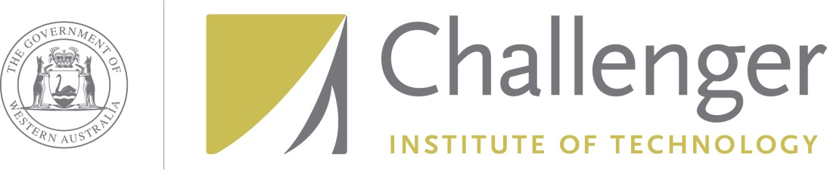

What is a contract?

A contract is a legally binding agreement between two or more persons. For example, if you purchase any goods, buy a house, engage a builder to carry out work on your house, borrow money, order goods or machinery from a manufacturer, or sign up for a telephone plan, these are all types of contracts.

The law of contracts is vital to the law which affects consumers. It is a complex area and is governed both by the "general law" – that is, laws which have evolved from decisions made over the years by Judges in relation to contract disputes and secondly, "legislation" or "statutory law" - laws introduced by government. Examples of these types of statutory laws are the *Sale of Goods Act*, the *Trade Practices Act*, the *Fair Trading Act*, the *Credit Act* and the *Contracts Review Act*.

**Who can make a contract?**

In New South Wales a person is able to make a contract when they reach 18 years of age. However, there are some circumstances when a person who is younger than 18 will be bound by a contract into which he or she has entered. Basically, it depends on the type of contract and the degree of understanding that the person had about the contract. In certain circumstances a person who is mentally ill or intellectually disabled at the time may not be bound by a contract entered into.

**What makes a contract?**

A contract involves certain basic elements. They are:

* Agreement (arising from an offer and an acceptance);
* Consideration - an exchange of some benefit or something of value by the parties, for example a party pays a sum of money for goods supplied by another party, or money is paid for work carried out by the other party; and
* An intention to enter into legal relations - that is, the parties intended to enter into a legally binding agreement (although this is often not specifically stated, it is usually implied).

The parties must also have the legal capacity to enter into a contract, for example as discussed above, in relation to age and mental capacity.

**Who decides the terms of a contract?**

Generally the terms of a contract are for the parties to decide. However, the law may 'imply' terms into the contract. One implied term is that goods sold for a particular purpose are able to be used for that purpose - for example that a machine which is sold as a clothes dryer will dry your clothes.

Under the New South Wales *Contracts Review Act* the terms of a contract may be altered or disregarded if they are unjust or result from duress or unequal bargaining power. However, the courts do not try to draw up contracts for parties.

**What is an unjust contract?**

The *Contracts Review Act* describes an unjust contract as one that is unconscionable, harsh or oppressive. It applies to contracts in connection with land, goods or services for personal use but not if the contract was entered into by you in the course of a trade, business or profession. For instance, an unjust contract could be one where one party has been tricked or pressured by the other, or where a person has been encouraged to enter a contract by another party who was aware of the person’s inability to understand the terms of the contract. Some of the things a court will look at when deciding if a contract is unjust or harsh include unequal bargaining positions of the parties; unreasonable or difficult-to-comply-with conditions in the contract; and the opportunity the parties had to obtain independent legal advice. If you think you are the victim of an unjust or harsh contract, discuss the matter with your Solicitor to find out if you have a case under the Contracts Review Act.

**Does a contract have to be in writing?**

Generally contracts do not have to be in writing, but there are particular cases when the contract must be in writing for it to be binding, for example guarantees, the sale of a house, and credit sales or other credit agreements.

However, it is usually better to have the details of an agreement and any variation in writing so both parties have a record of what has been agreed and are aware of what they are obliged to do, particularly when money is involved.

**Are you bound by a clause you did not read?**

If you sign a written contract then generally you are bound by all of its terms even if you did not read or understand them.

There are various types of contracts which you may come across in everyday life which do not require your signature, for example, a car park ticket or a dry cleaning docket which has clauses printed on the back. Generally the rule is that you are bound by the clauses if you have read them or if you knew they were there but did not bother to read them, or if the other person took reasonable steps to draw them to your attention.

It is therefore extremely important that you read all the terms of a contract before you enter into it. You should not sign any document until you are fully aware of what its terms and conditions are and what they mean.

**What happens if the terms of a contract are broken?**

Once you make a contract you will be committing a breach if you do not comply with its terms, or if you change your mind and decide not to perform your side of the contract.

If a party breaches a contract there are a number of remedies available, including:

* Damages (a sum of money) to compensate the 'innocent party for any loss suffered - this is the most common remedy;
* A court order requiring the party who has breached the contract to carry out his/her obligations;
* A court order forbidding the party from breaching the contract; and
* A court order declaring that the contract is at an end and requiring the party who has breached the contract to put the 'innocent party in the position he/she was in before the contract was entered into.

The type of remedy and its availability would depend very much on the type of contract and the type of breach. A Solicitor can advise you as to the best means of dealing with the problem.

  Taken from [http://www.lawsociety.com.au](http://www.lawsociety.com.au/)